How to drop an Assigned Program
You can’t drop a Program that you haven’t begun. If you haven’t started the program, begin with Step 1. If you have started the Program, proceed to Step 3.
- Locate the program under Required for You or Progress > Required
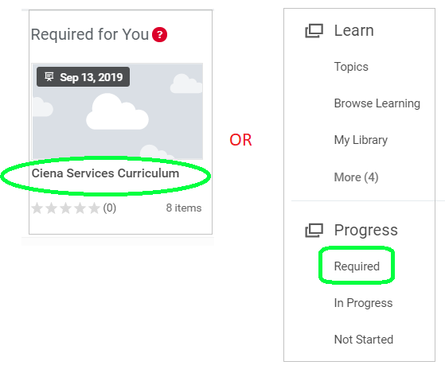
- Open the Program. Click Begin > View Content.

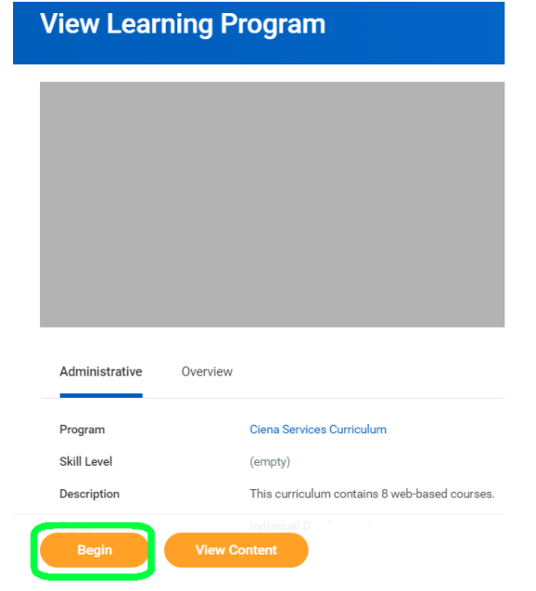 | 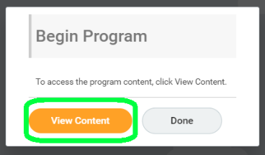

- Leave the Program (click the Ciena icon > Learning) and return to Required Learning.

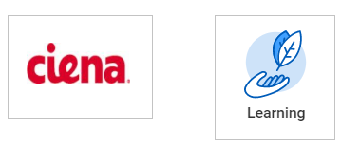 | 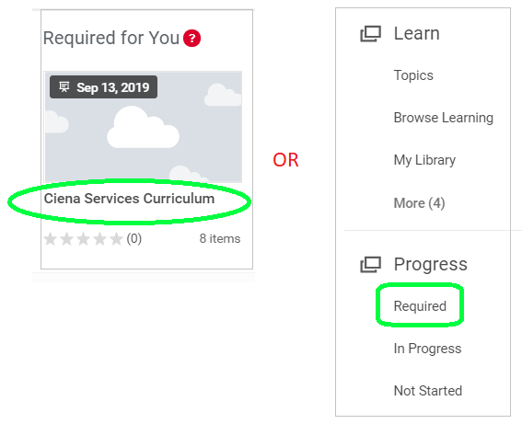
- Open the Program and click Drop.

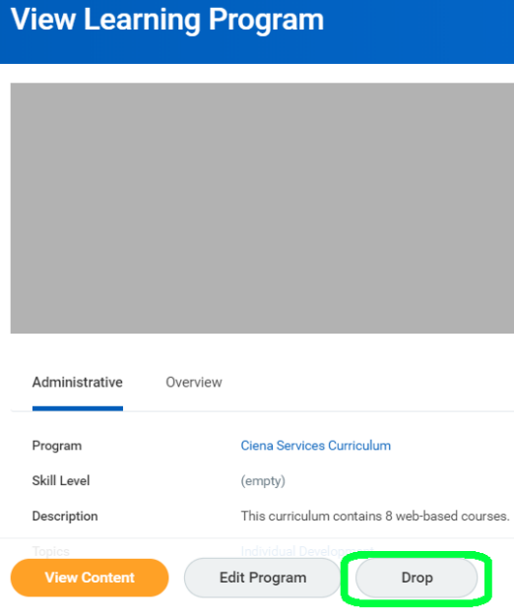

Admin Approval is required to Drop a Required Program. Once the Admin has received the notice from the system that you requested to Drop the Program, the Admin will seek approval from the Learning Business Partner and if “Approved” the Admin will approve the request and the Program will no longer appear under Required for You.

